Name : MUHAMMAD MUBASHAR ALI

Student ID : BSIET02213012

Subject : Object Oriented Programming

Lab : 04

Example # 01

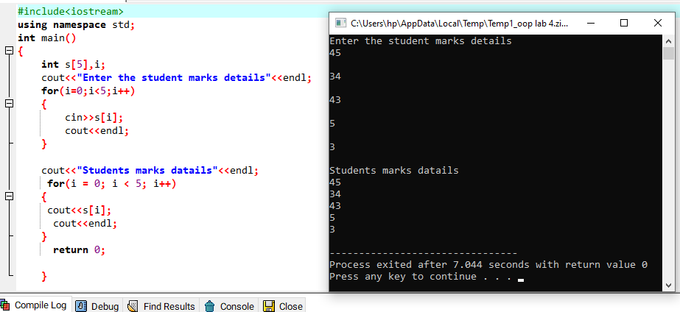

Example # 02

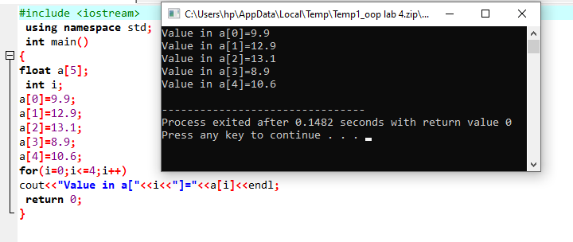

Example # 03

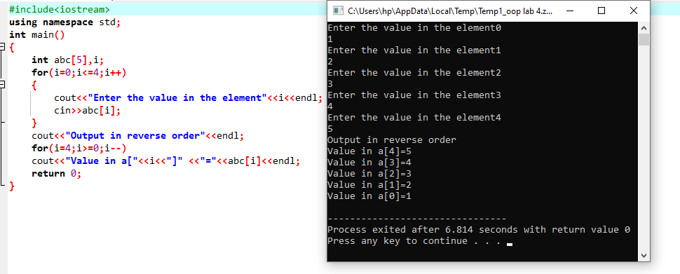

Example # 04

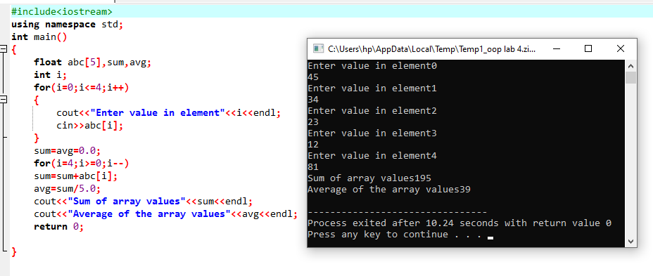

Example # 05

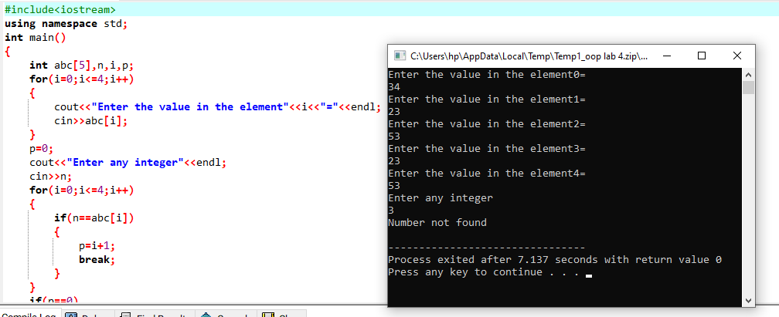

Example # 06

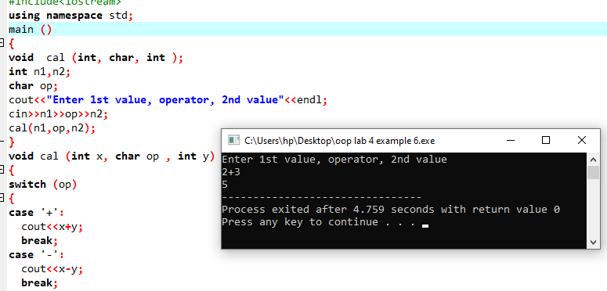

Example # 07

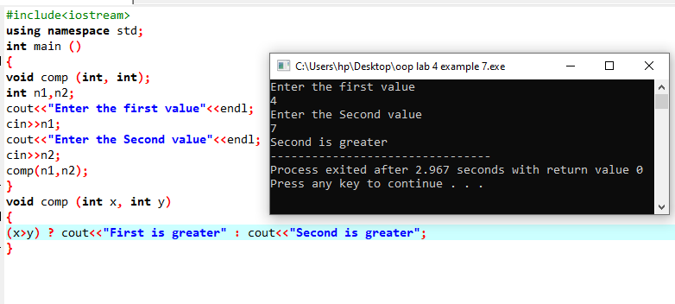

Example # 08

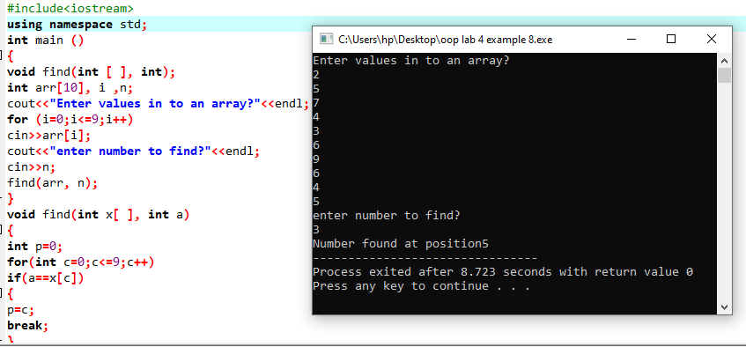

Example # 09

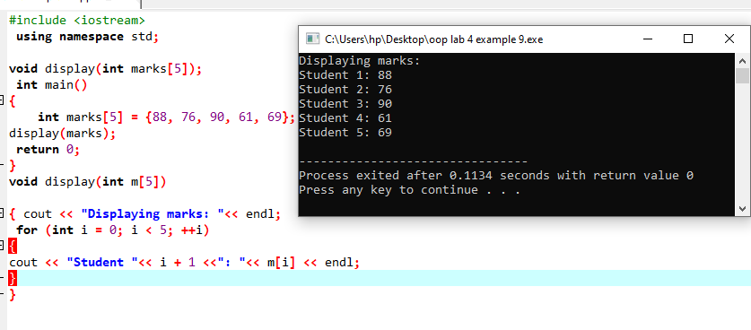

Review Questions

Question # 01

Write a program that inputs a value in to two linear arrays. It adds the two arrays and stores the sum in a third array. Further, it displays values of three arrays as follows

(First + Second= Sum )?

Answer

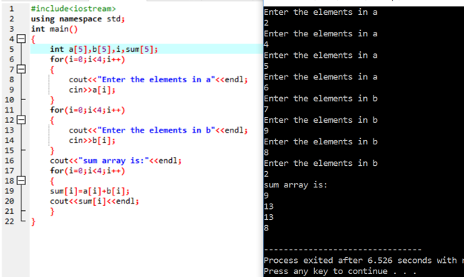

Question # 02

Write a program to sort the one dimensional array values as given below in to descending order using bubble sorting method.

Array Values are {55,41,12,78,1,69,45,4,36,5}?

Answer

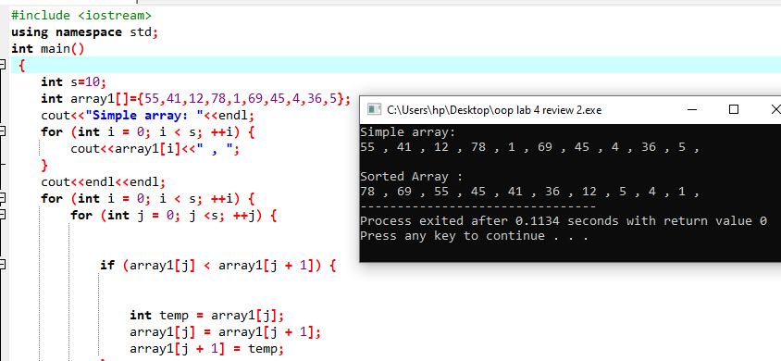

Question # 03

C++ Program to display marks of 5 students by passing one-dimensional array to a function.?

Answer

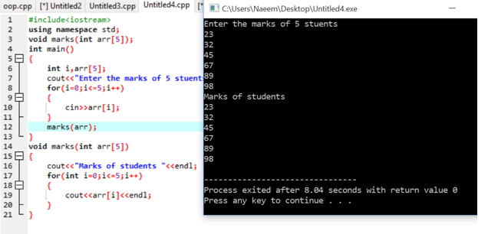

Question # 04

C++ Program to Find the Number of Vowels, Consonants, Digits and White Spaces in a String?

Answer

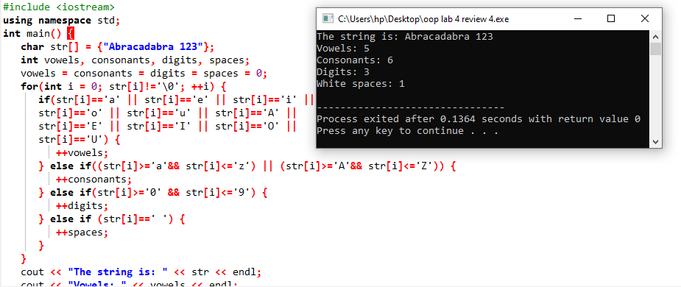

Question # 05

Write a program to find the minimum number from an array by using the function?

Answer

